**Transaction using SepoliaETH**

1. Open MetaMask and click on the Ethereum Mainnet dropdown

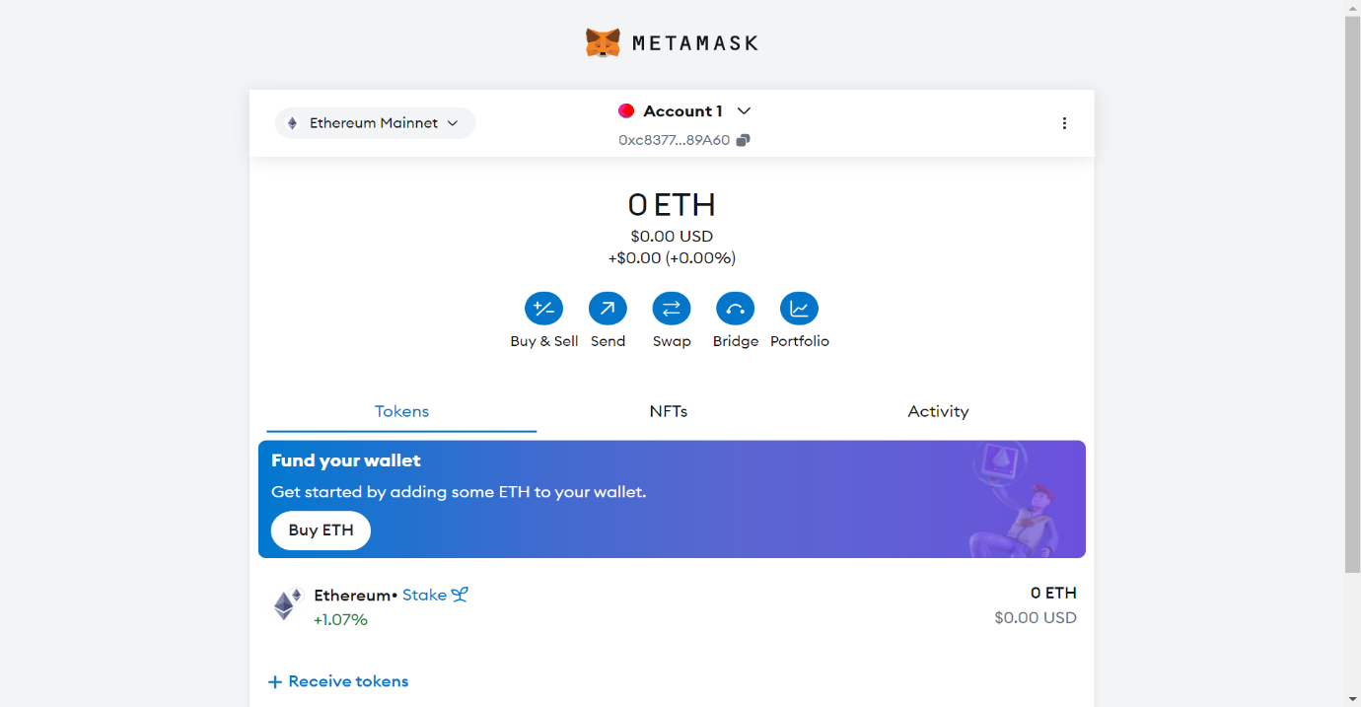

1. Click on show test networks toggle button

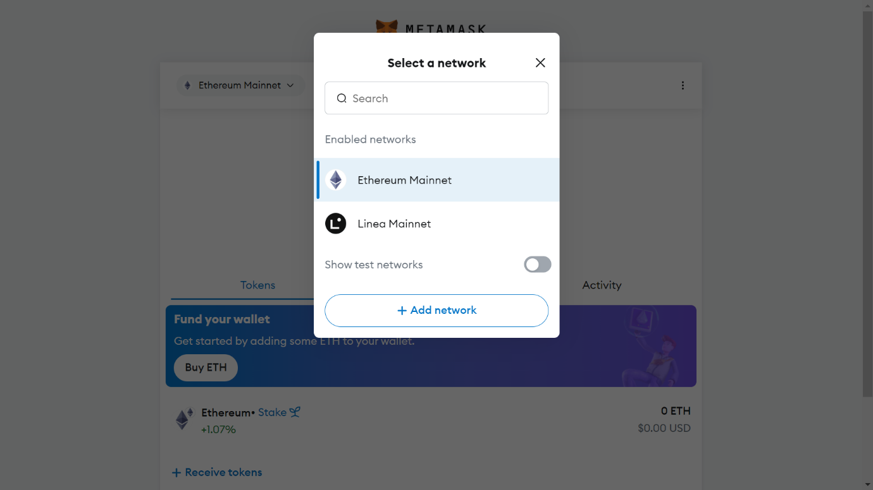

1. Select Sepolia

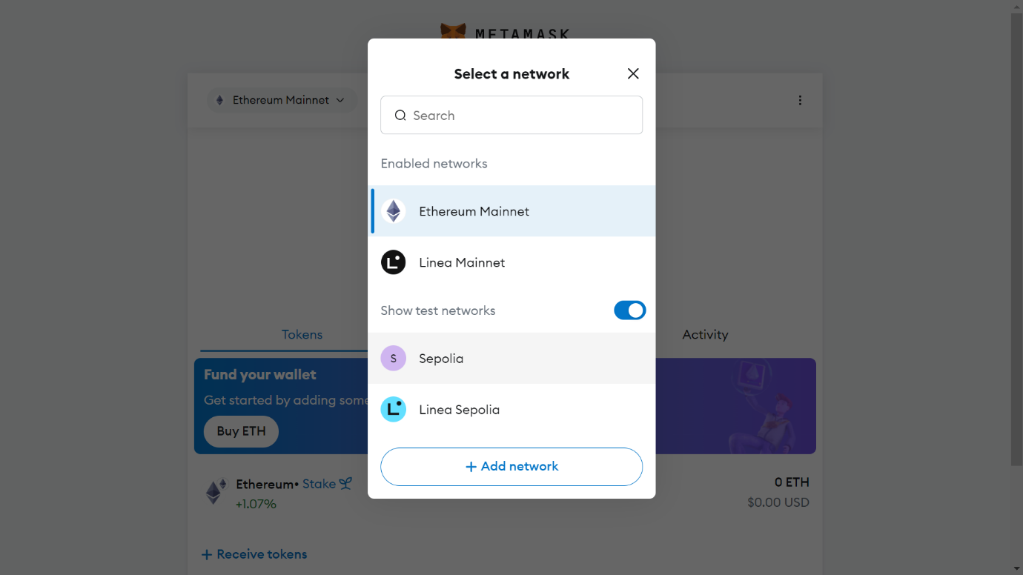

1. You can see your SepoliaETH holdings here.

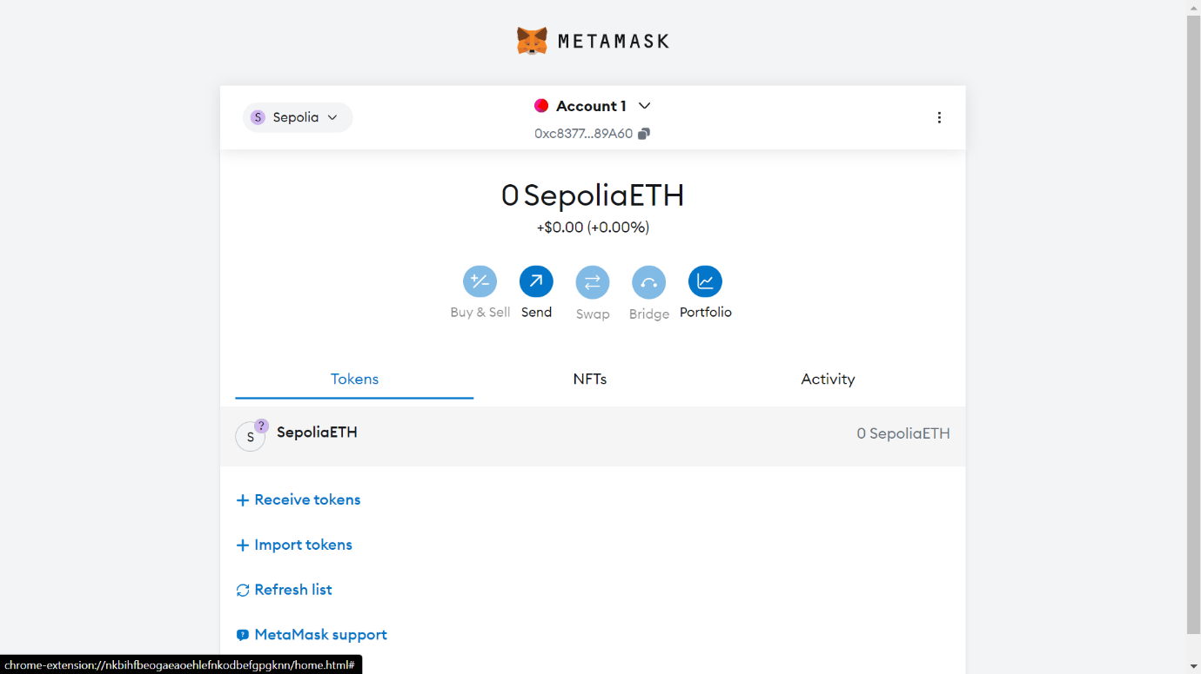

1. Copy the public address of Account 1.

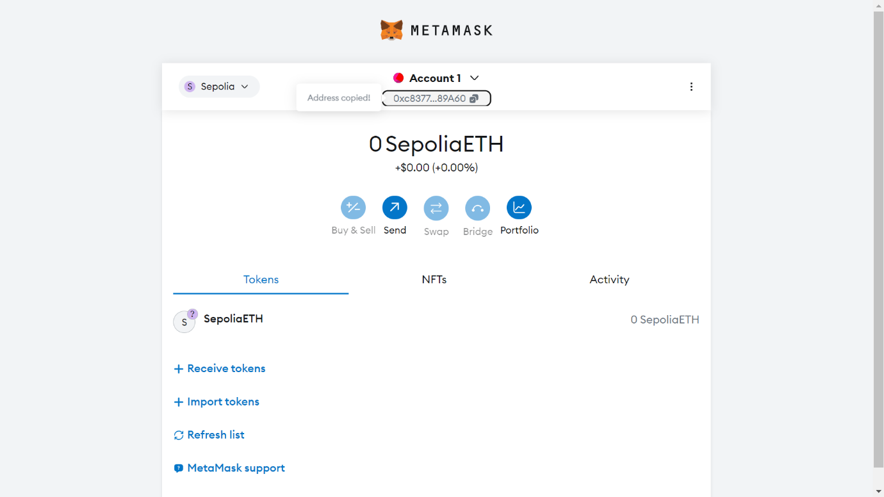

1. Go to: - <https://cloud.google.com/application/web3/faucet/ethereum/sepolia> and paste the public address. Then click on receive button.

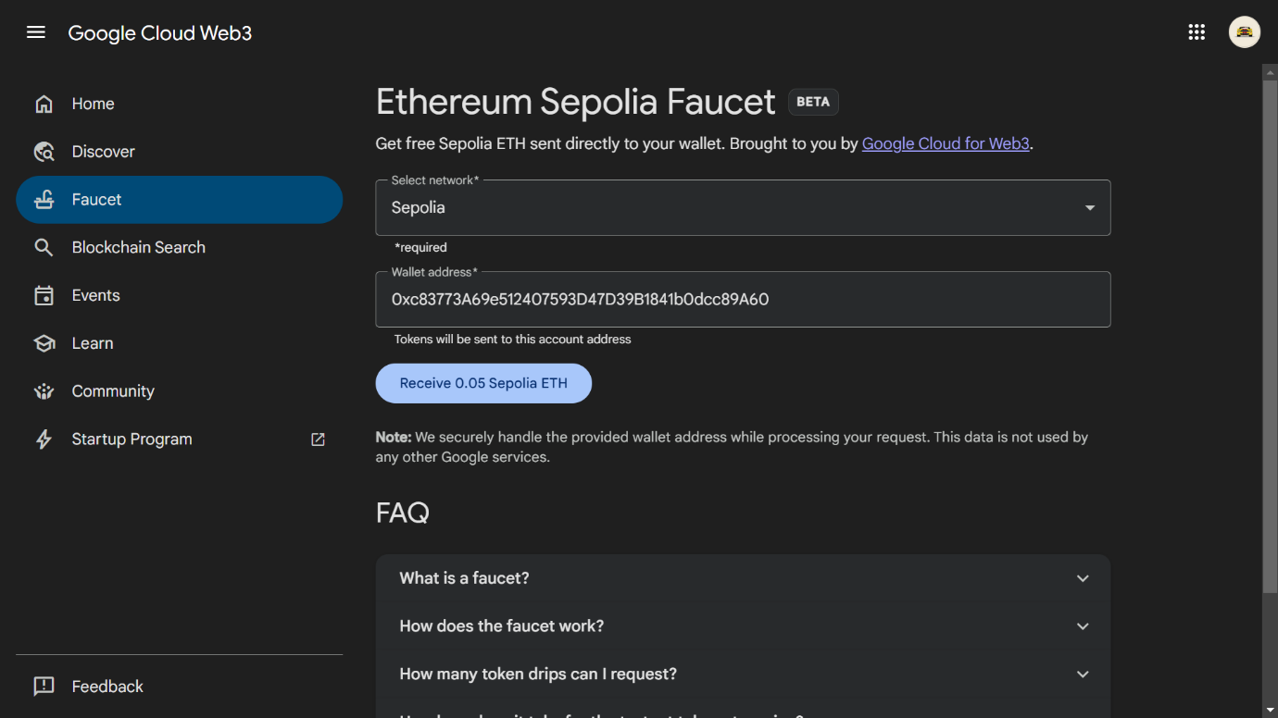

1. The transaction will be on queue, after some time a Drip complete message will show up.

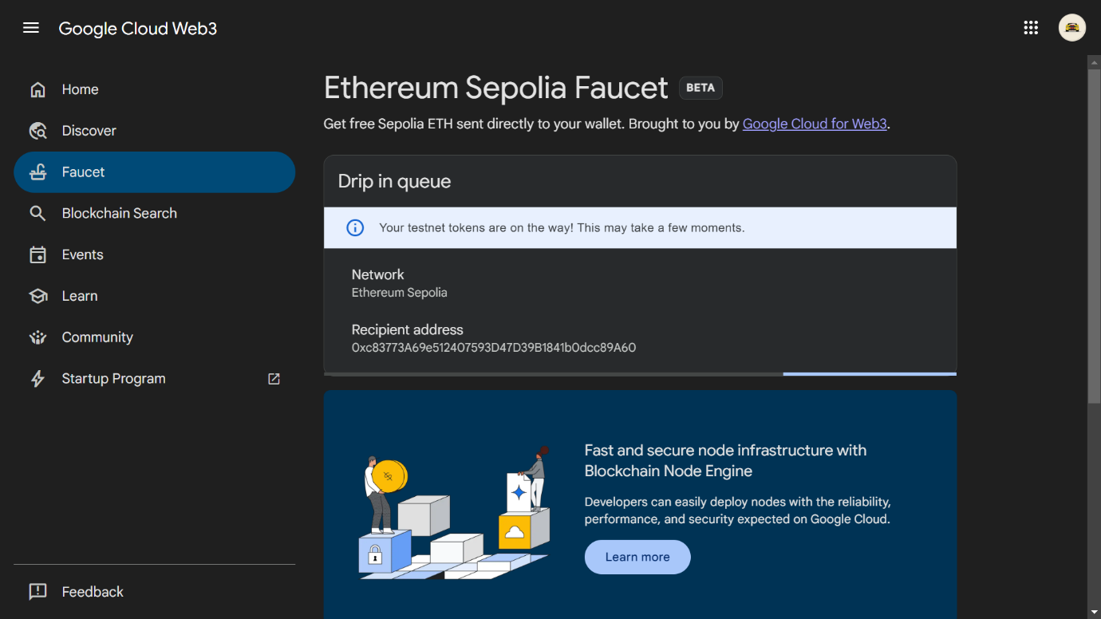

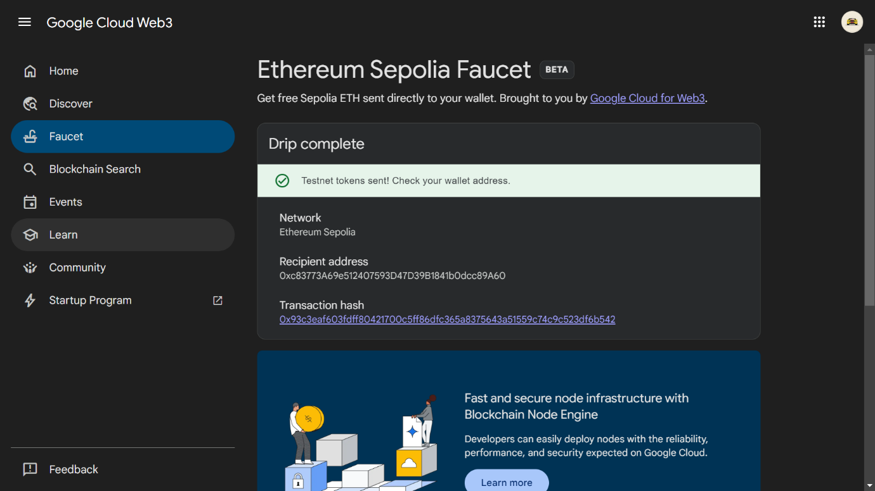

1. When you refresh your account in MetaMask you will see 0.05 SepoliaETH credited in your account. Then click on Account 1 dropdown.

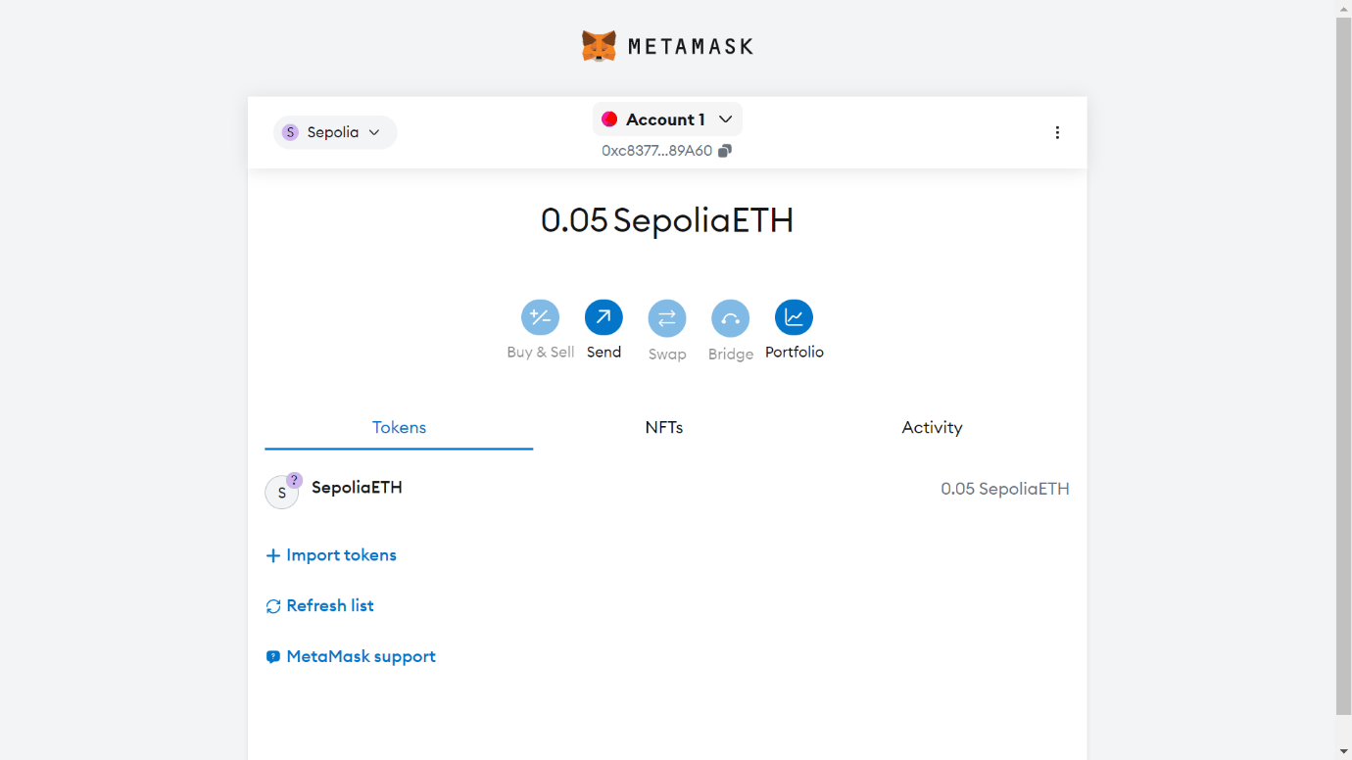

1. Click on Add account button.

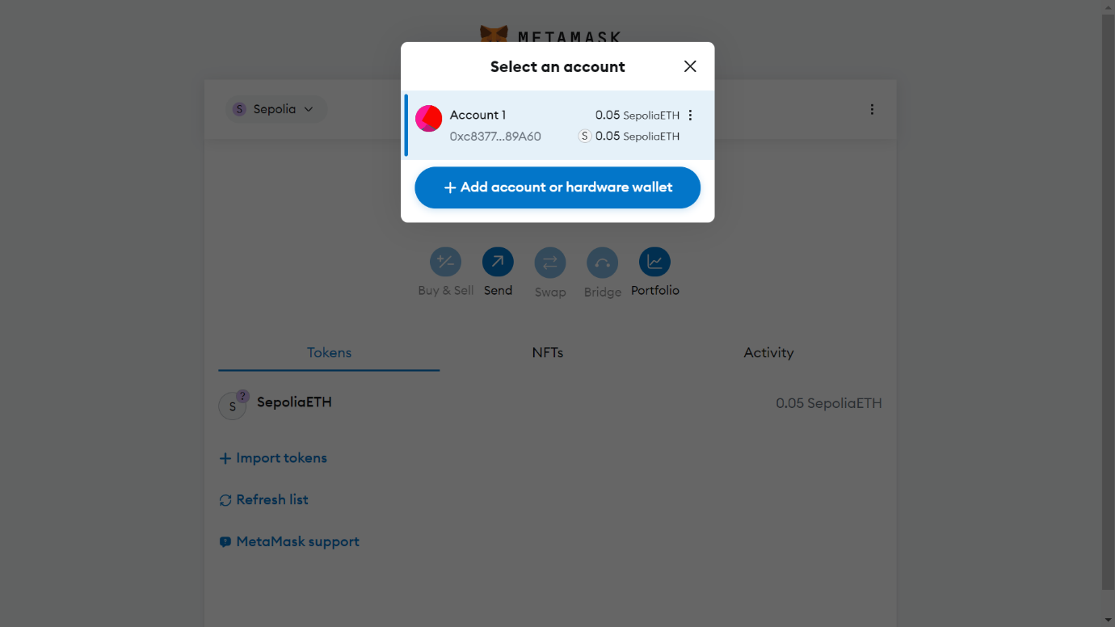

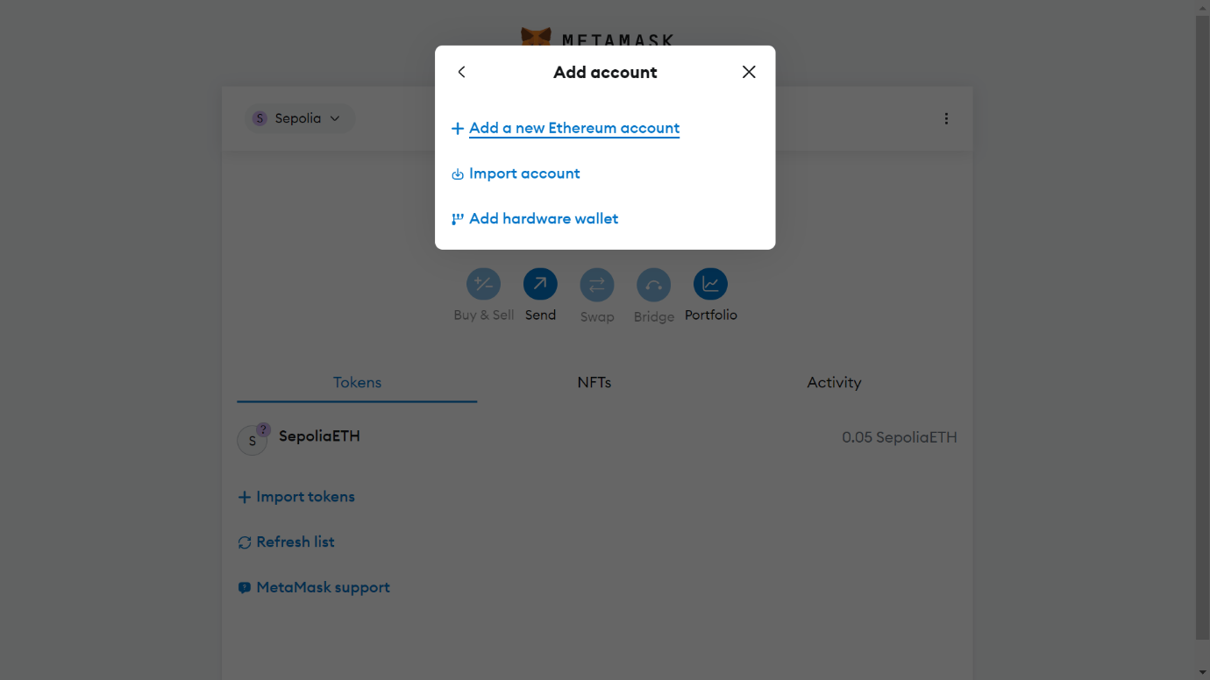

1. Give a name to your account.

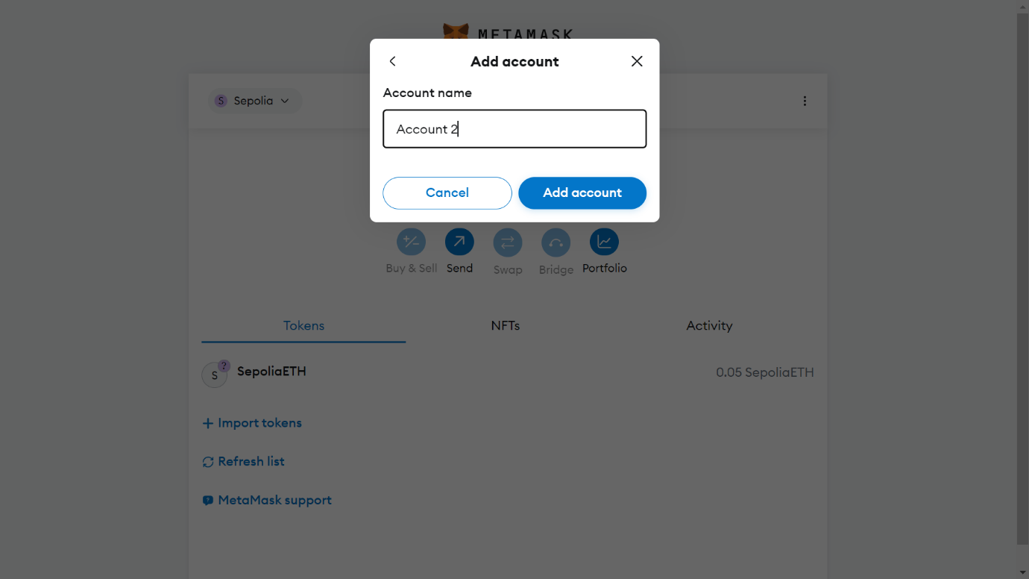

1. Your new account will be created. Click on the new account.

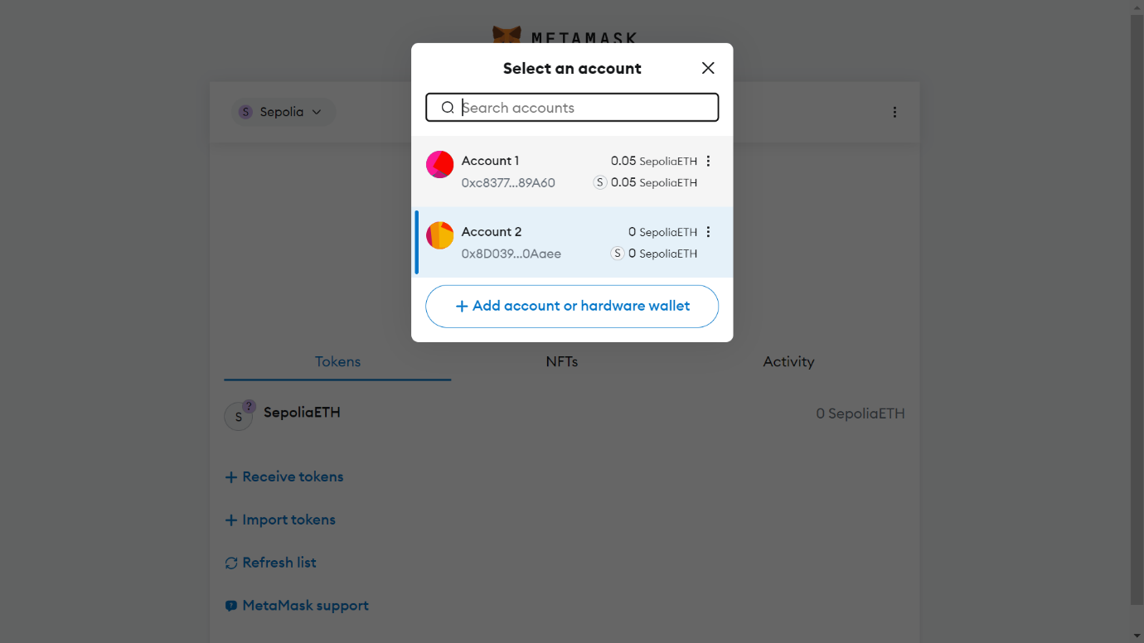

1. Copy the public address.

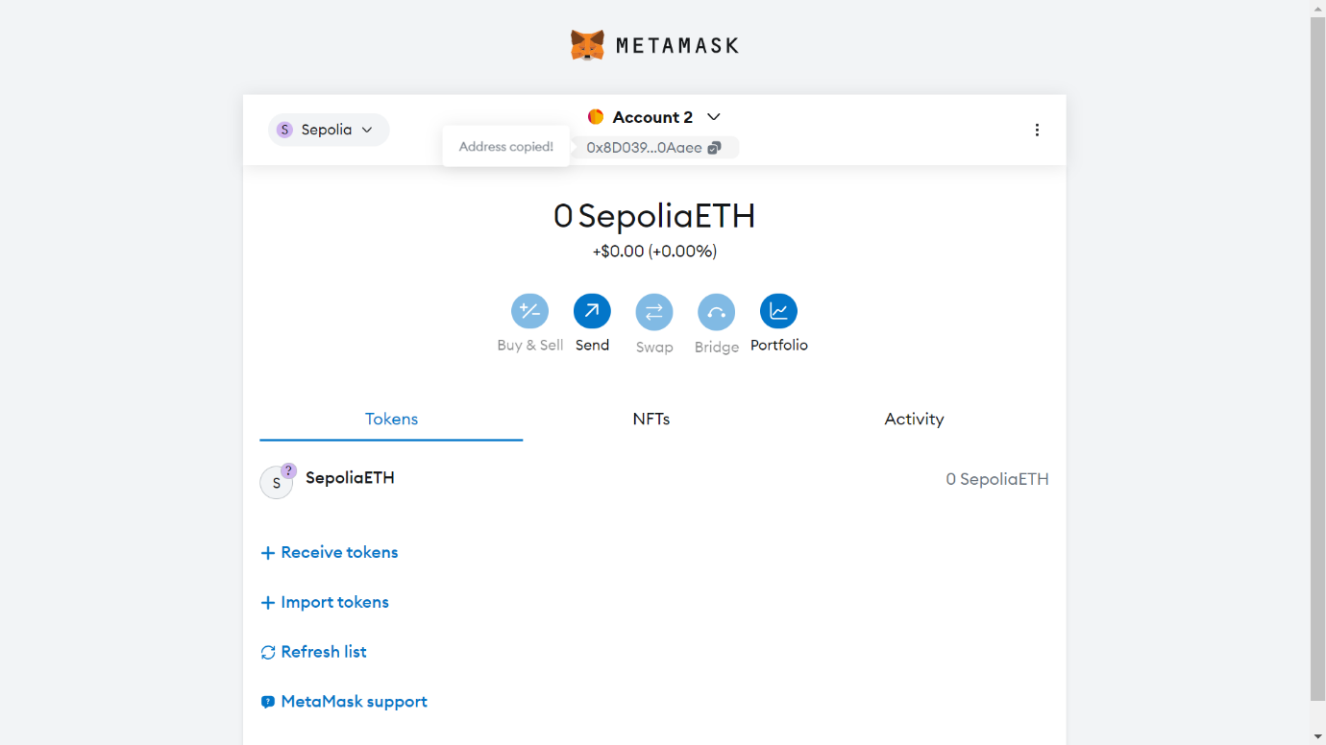

1. Go to account 1 and click on the ‘send’ button. Paste the public address in the ‘To’ textbox.

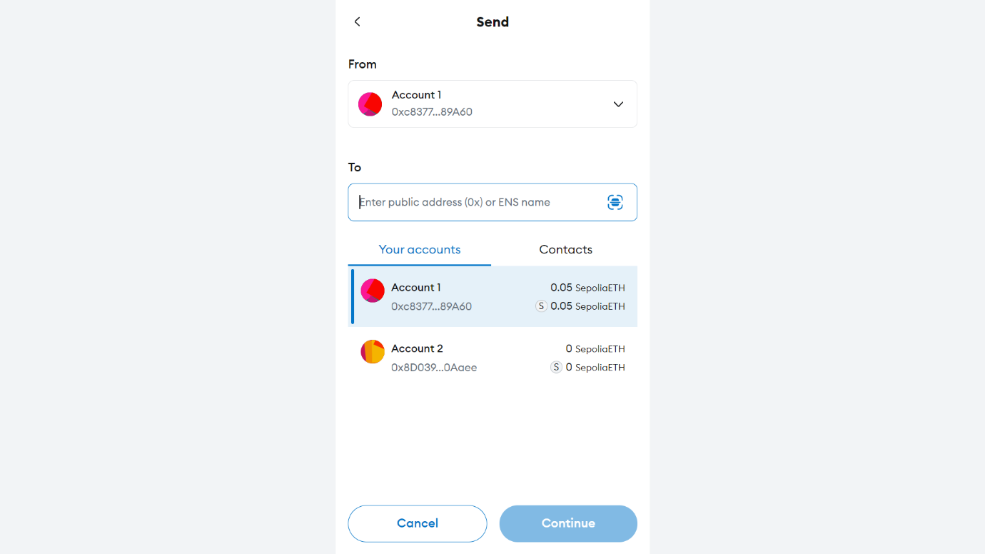

1. Enter the amount to send.

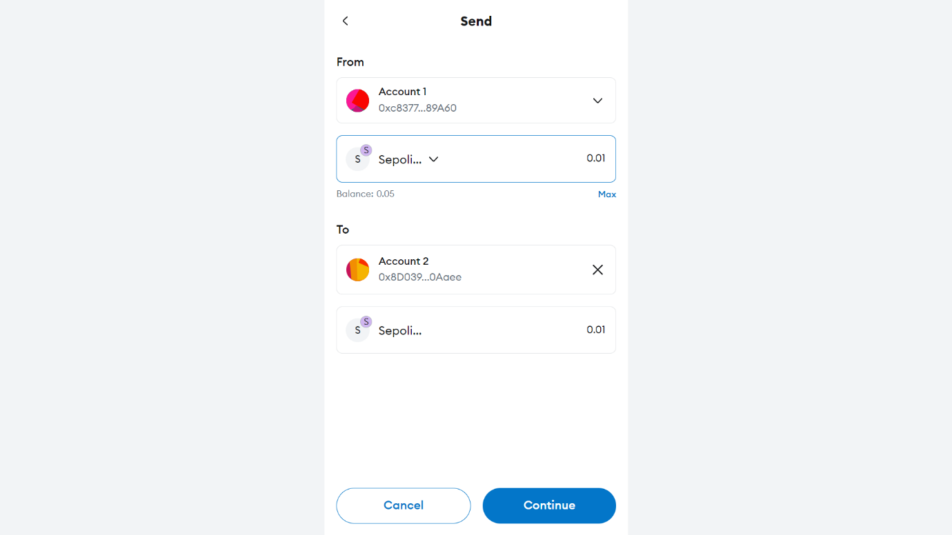

1. Notice here some of your amount is deducted as transaction Fee for mining process. Click on ‘Confirm’.

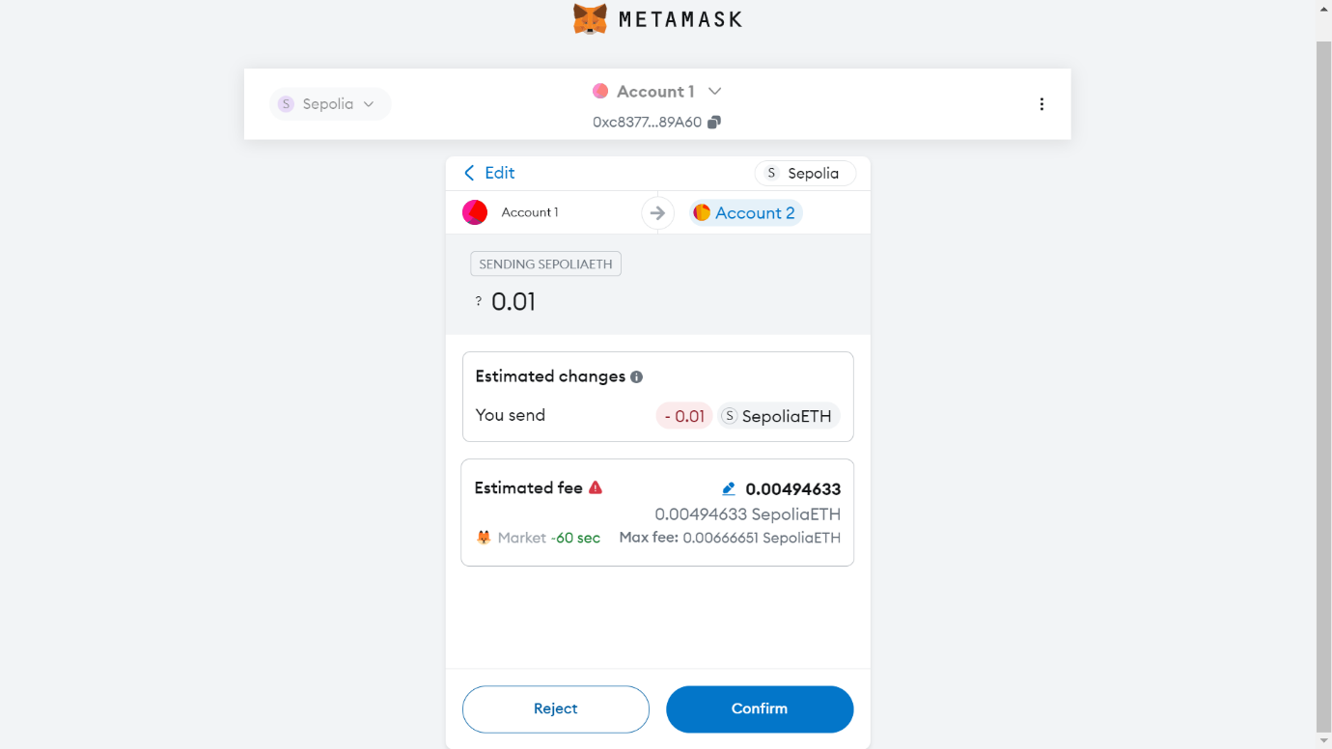

1. You can speed up your transaction by clicking speed up button.

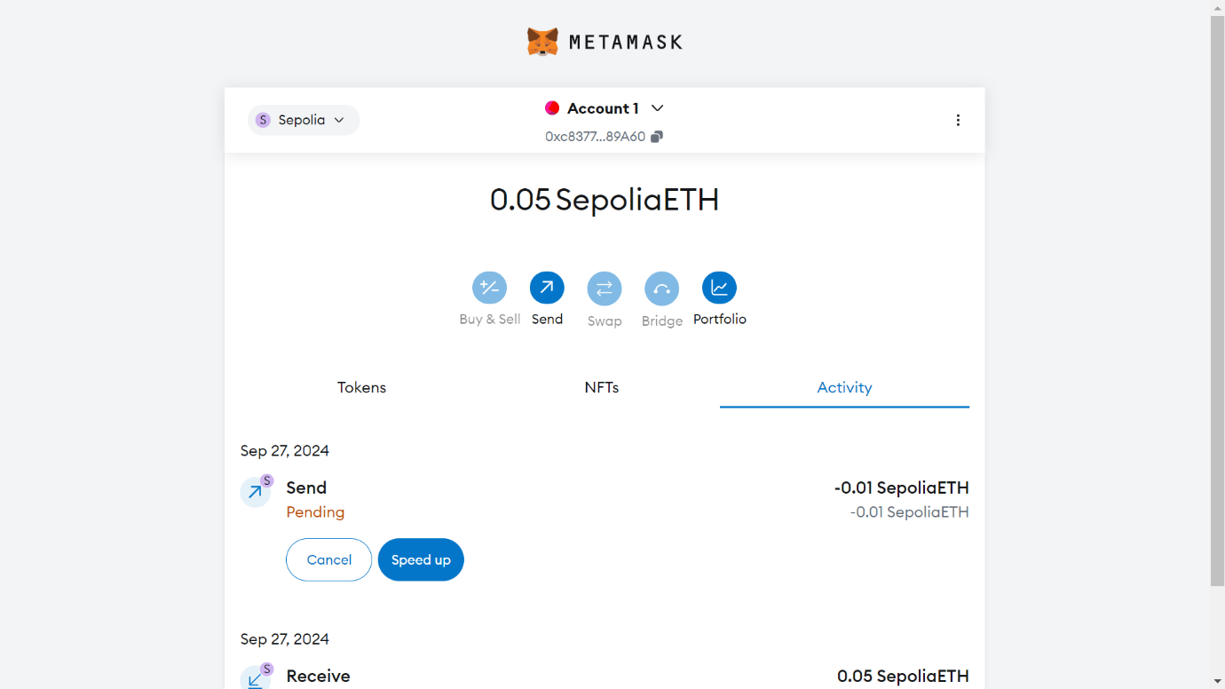

1. When the transaction is completed the amount will be deduced from your account.

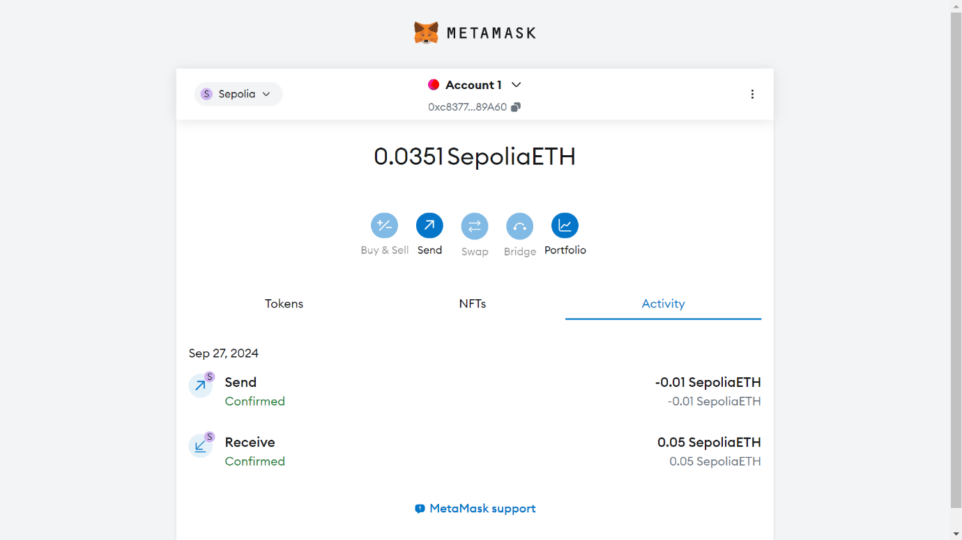

1. Go to your new account and see the credited amount.

